Name: Maloth Aditya
Roll No.: 120CS0124

Activity Diagram
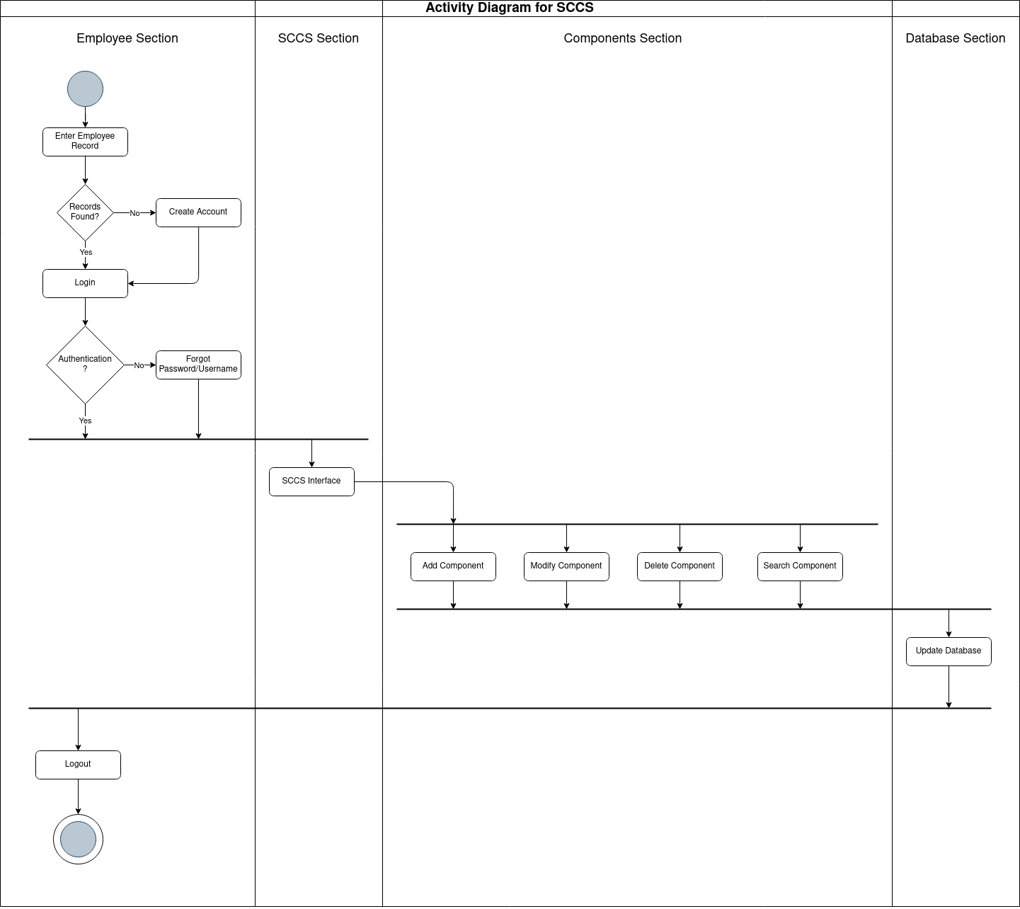

State-Chart Diagram

